This report details the individual design project of Jacob Mader, which applies the concepts from the ECE326 course Electric Networks. The project analyzes the frequency content of a supplied time-domain waveform using the Fourier Transform, proposes a design for a frequency selective circuit in order to remove unwanted components from the supplied waveform, and analyze the effects of using "real" component values to realize the circuit. In order to complete these tasks, MATLAB and LTSpice were used to analyze, design, and simulate electric networks.

**Fourier Transform:**

A provided measured signal of an output voltage in the time-domain was corrupted by noise and other signals. A filter circuit that can remove the noise needed be designed. The only information regarding the signal was that the frequency of interest had the largest amplitude when viewed in the frequency domain. The provided sample was found in the provided file, ‘ECE326_Spring2020_FinalProject.mat', which contained two variables: S (measured voltage in the time domain) and t (corresponding time vector to the measured voltage). Using this data, the signal was imported MATLAB and used to plot the signal in both the time and frequency domains. The MATLAB code used to produce these plots, as well as the plots themselves are shown below as Figures 1, 2, and 3.

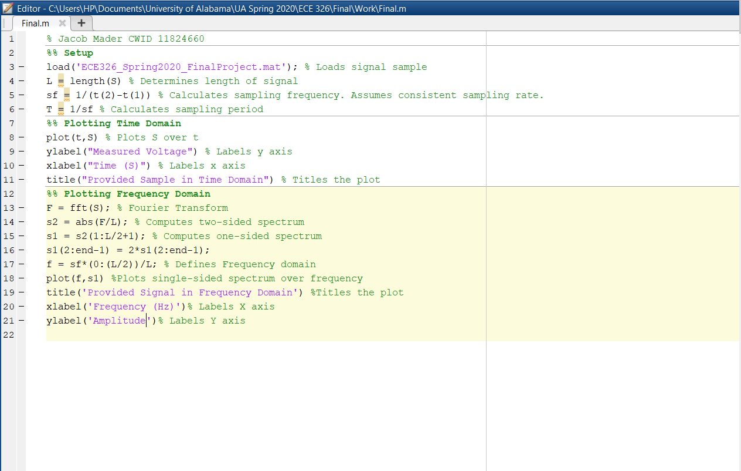

Figure 1. MATLAB Code.

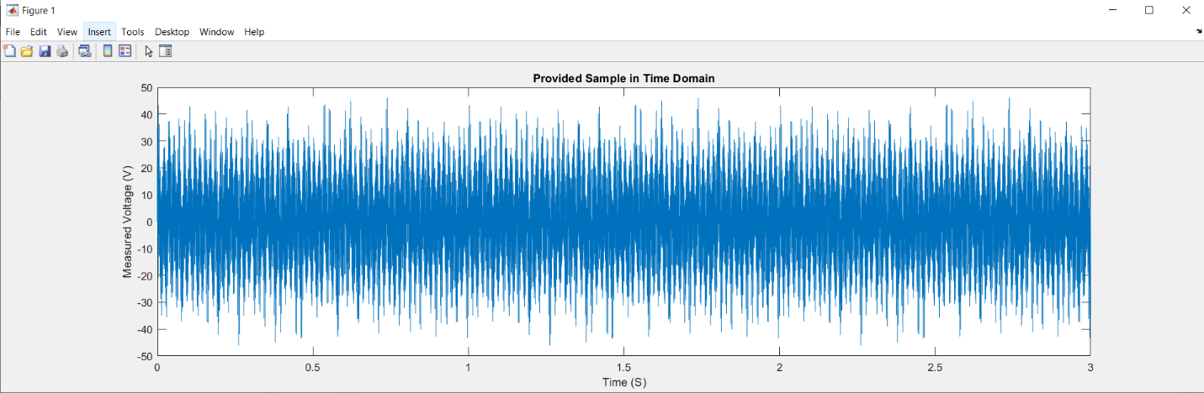

Figure 2. Plot of signal in time domain.

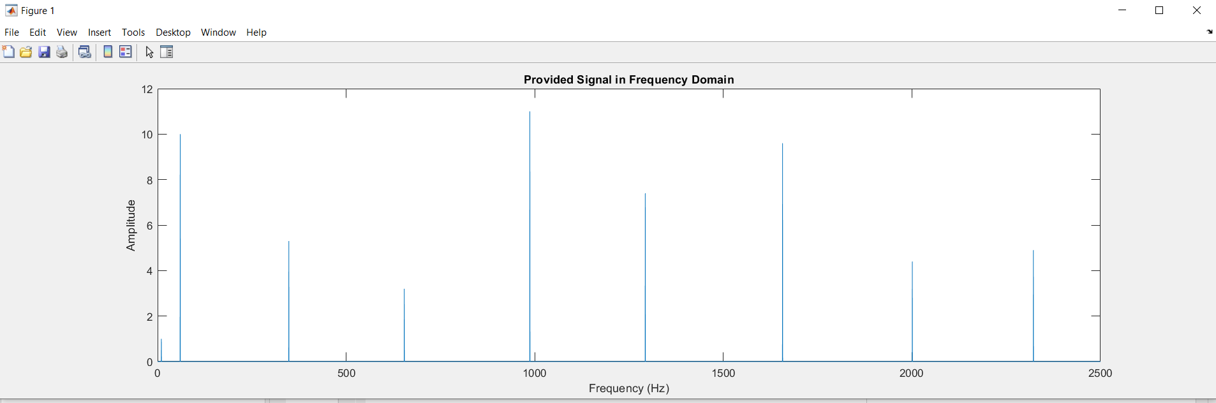

Figure 3. Plot of signal in frequency domain.

The frequency of interest we know to be that which has the largest amplitude when viewed in the frequency domain. Examining Figure 3, the highest amplitude observed is that of 11. This amplitude occurs at 987 Hz, or alternatively 6,201.5 rads/s, which we now know to be our frequency of interest. Eight sources of noise could be seen to occur in addition to our signal of interest. These occur at frequencies of 10 Hz, 60 Hz, 348 Hz, 654 Hz, 1293 Hz, 1657 Hz, 2000 Hz, and 2322 Hz, with amplitudes of 1, 10, 5.3, 3.2, 7.4, 9.6, 4.4, and 4.9, respectively.

**Filter Topology Selection:**

Based on the results of the FFT, it could be seen that noise would occur at frequencies both above and below our frequency of interest, and so a bandpass filter circuit was the appropriate choice of filter circuit for this signal, as this type of filter can filter out noise responses both above and below specific frequencies. These results also allowed for the estimation of the desired resonance frequency and bandwidth characteristics of the filter. The results indicated that the frequency of interest is 987 Hz or 6,201.5 rad/s, so an estimation for the desired resonance frequency to be 987 Hz or 6,201.5 rad/s was made, so that the filter would be centered on the frequency of interest. The results also showed that no additional significant responses occur at frequencies within 10 Hz of our frequency of interest. This suggests that a bandwidth of 20 Hz or 125.66 rad/s would be appropriate, and so an estimation of 20 Hz or 125.66 rad/s was also made.

The sample signal with an overlaid image of the ideal filter response is shown below as Figure 4.

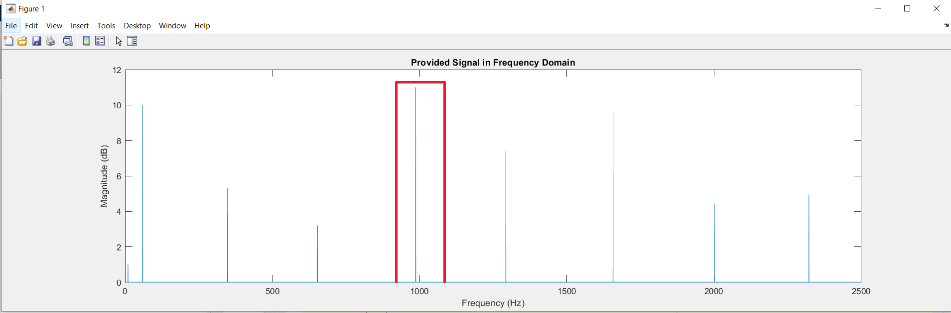

**Filter Design:**

Figure 4. Plot of signal in frequency domain with ideal filter response.

To realize the bandpass filter, a series RLC circuit topology was used. This topology consists of an inductor and capacitor in series, followed by a resistor. The inductor acts as a low pass filter while the capacitor acts as a high pass filter, these two behaviors combined linearly result in the bandpass filter behavior which was expected to be produced. The order of these components does not matter, because it does not matter whether low frequency or high frequency signals are filtered out first in a bandpass filter. The resistor must come last however, as the observed output voltage would show a response to these low or high frequency signals if they were to be filtered after passing through the resistor. The series RLC bandpass filter topology can be seen in Figure 5.

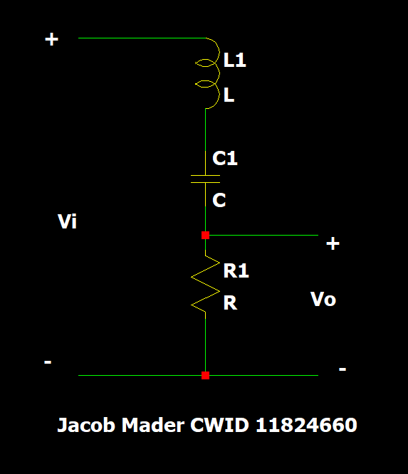

Figure 5. Series RLC bandpass filter topology.

The transfer function of this filter could be derived as well. The transfer function could be defined as the output voltage divided by the input voltage at any given time. Thus with some algebraic manipulations, the transfer function could be found that .

Additionally using the formulas and and assuming an inductor value of would be used, a resistor value of  Ω and capacitor value of could be calculated as those values which would produce the desired bandwidth and resonance frequency characteristics. The hand derivations for both the transfer function and the component values are shown here as Figure 6.

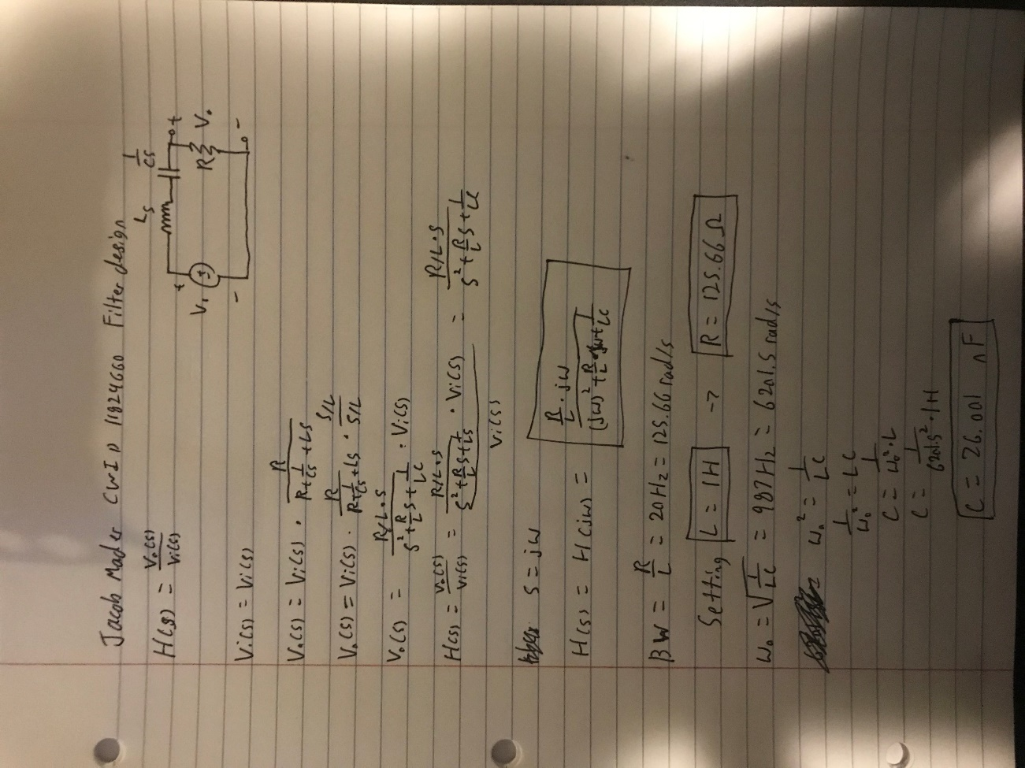

Figure 6. Hand derivation of transfer function and component values.

**Filter Simulation:**

To validate that the hand-derivation of the transfer function and selection of components was correct, this circuit was simulated and the frequency response observed using LTSpice. This simulation was an AC analysis (.ac) and used an AC voltage source with an AC amplitude of 1 V. Also, this simulation used the same frequency bounds as the initial FFT frequency analysis. The simulated circuit and the ac simulation of the circuit’s frequency response as well as a simulation of the derived transfer function are shown in Figures 7 and 8.

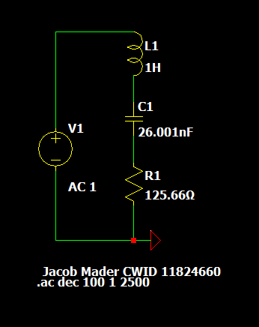

Figure 7. Simulated circuit.

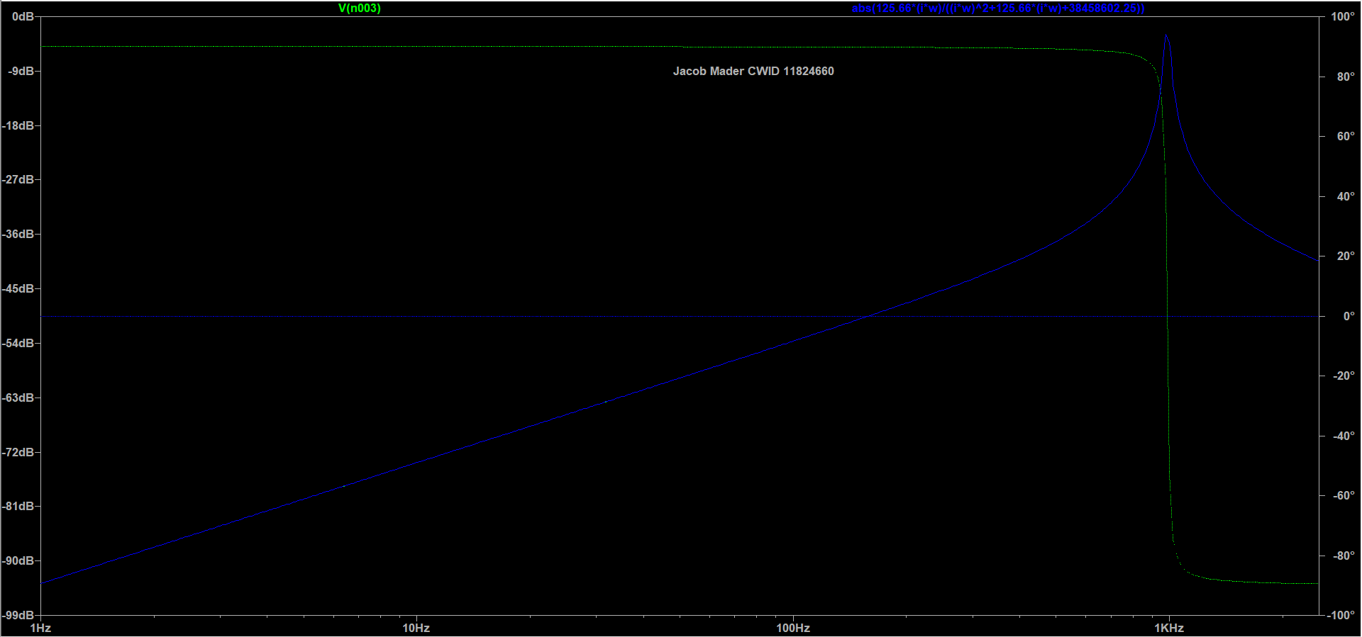

Figure 8. AC simulation results

These simulations confirmed that the derived transfer function accurately represented the designed bandpass filter, as both the simulated circuit and the transfer function result in the same plots.

**Realistic Components:**

These component values however may not actually be available in real life. Realistic components which could be used to construct this filter were found on [www.digikey.com](http://www.digikey.com). The components selected can be viewed as a table in Figure 9.



Figure 9. Table of real components

Using these values to simulate a “real” circuit, in addition to an “ideal” circuit, comparisons could be made from the magnitude and phase responses of the two circuits. These circuits and their responses, with green indicating the original “ideal” circuit and blue indicating the new “real” circuit, can be seen here as Figures 10 and 11.

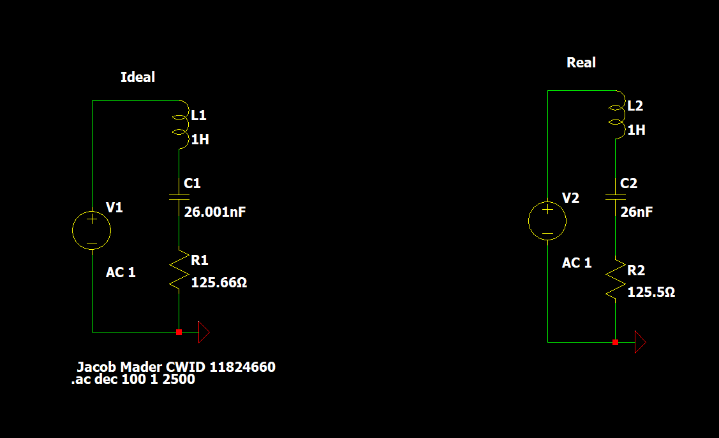

Figure 10. Ideal and real circuit.

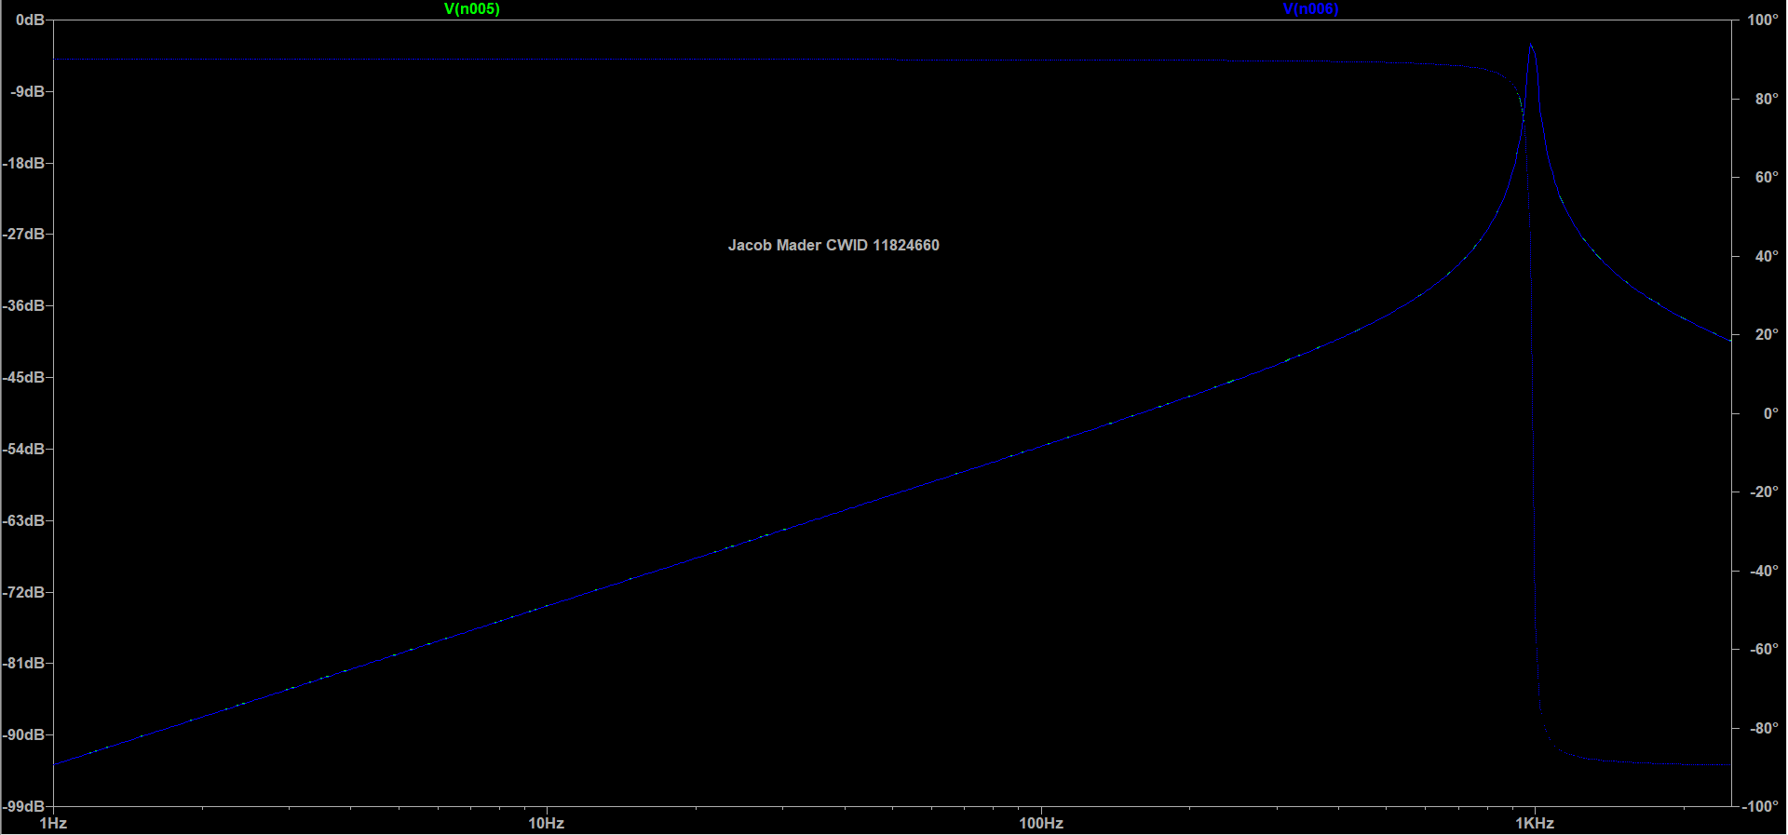

Figure 11. AC simulation of ideal and real circuit.

The “ideal” and “real” responses are very similar, with extremely minor differences. This is because the “real” components available had very similar values to the “ideal” components. Despite the similarity between the two plots, numerical differences can be found. Calculating the resonance frequency and bandwidth of the two circuits using and , we can find that the resonance frequency actually has shifted slightly from 6201.6 rad/s to 6085.8 rad/s, or from 987 Hz to 968.6 Hz, and the bandwidth has shifted from 125.66 rad/s to 125.5 rad/s, or 19.999 Hz to 19.973 Hz. These changes are significant, because despite the relatively small changes to the resonance frequency and bandwidth, this shows that realizing an “ideal” circuit with “real” components can lead to a circuit with different characteristics than expected, which may be trivial in some cases, but life-threatening in other cases.

**Component Tolerances:**

Component tolerances can also result in characteristics different than those expected when not considering tolerances. Examining the resonance frequency equation once again, , we can see the resonance frequency shares an inverse relationship with L and C. This means that increasing L or C will result in a decreased value for , and similarly decreasing L or C will result in a increased value for Thus the worst cases would be when both the inductor and capacitor values are at their lowest tolerance points and at their highest tolerance points. Specifically the highest resonance frequency that this circuit could obtain would occur when L and C are at their lowest values, 0.9L and 0.9C, and the lowest resonance frequency obtainable would occur when L and C are at their highest values, 1.1L and 1.1C. Hand calculations of these two worst cases are shown here in Figure 12.

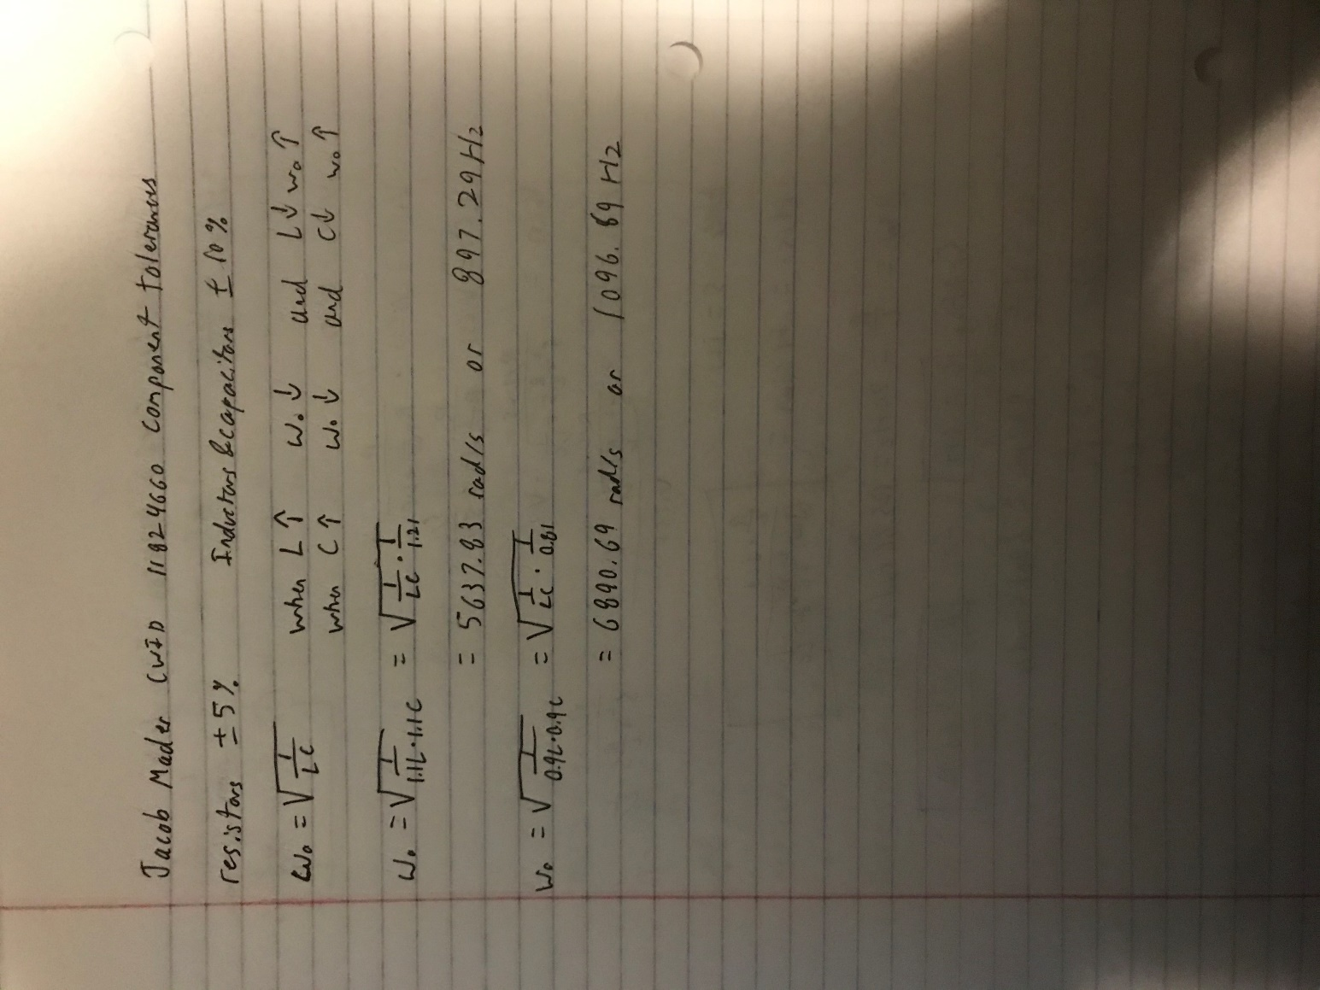

Figure 12. Hand calculations of upper and lower bound worst cases.

These calculations allowed for the estimation of a range of resonance frequencies between 5673.83 rad/s or 897.29 Hz and 6890.69 rad/s or 1096.69 Hz to be producible using these components. In the case of the lower and upper bound worst cases, the amplitude also changes, as the transfer function is also affected by the change in component values. In both cases, the amplitude approaches zero, as the changes in resonance frequencies have shifted the filter so that the original resonance frequency is no longer within the bandwith of the filter. These amplitudes do not actually reach zero however, and in the case of the lower bound the amplitude can be observed at roughly 96.6 mV and in the case of the upper bound the amplitude can be observed at roughly 107.07 mV. These significant drops in amplitude from a 1 V input signal confirm our understanding that the due to the change in resonance frequency, the input signal at the original frequency is being filtered out of the output signal. These worst case circuits and their AC simulations, with green indicating the lower bound case and blue indicating the upper bound case, from which we observed these worst case amplitudes are shown below as Figures 13 and 14.

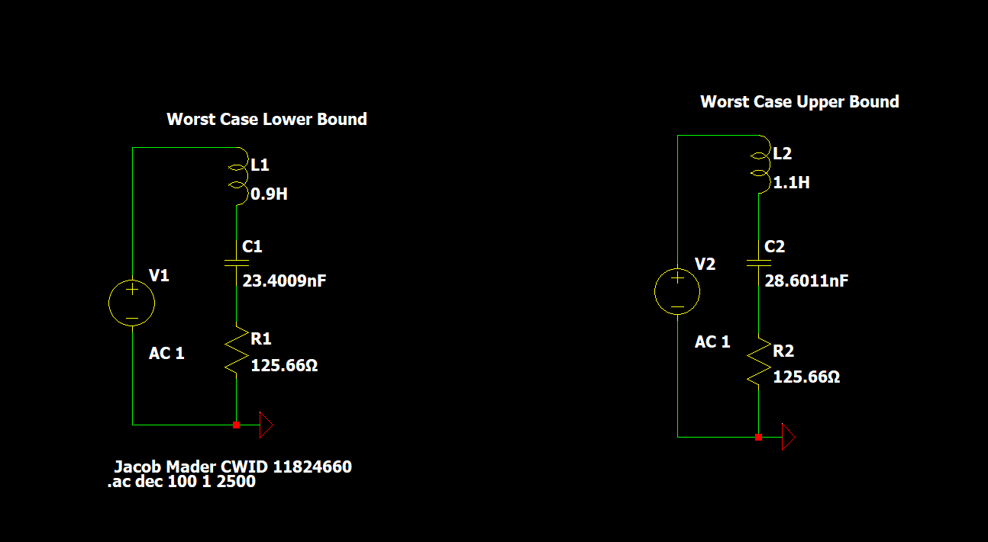

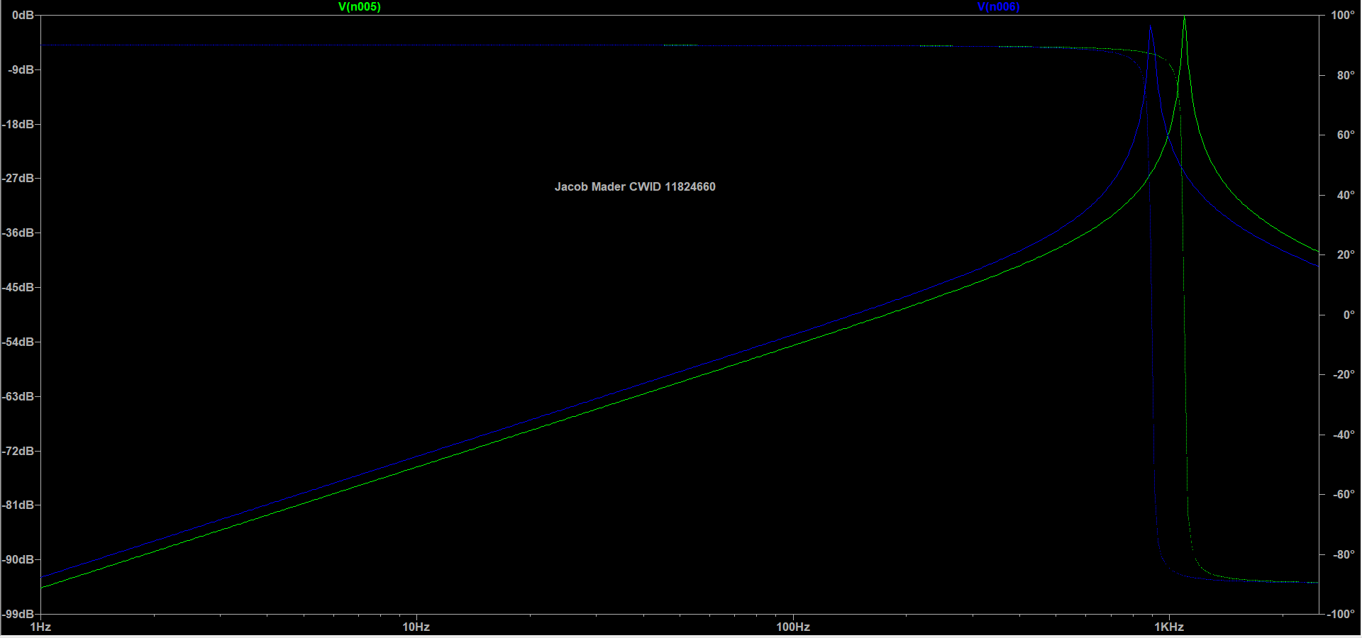

Figure 14. AC simulation of worst case circuits.

Figure 13. Worst case circuits.